SPARK: Simple Play Adaptations to Reference for Kids

GoTalk 4+ Lite Touch
Description: | Image:
The GoTalk 4+ Lite Touch is a 4-message static display augmentative and alternative communication (AAC) speech device that can assist children who need speech support throughout their daily activities. A message is recorded on each cell with pictures and/or words that represent the message added to a paper overlay that is inserted over the message cells. The total record time of all messages combined on the device is 4.6 minutes. The device has 5 levels, which allows messages to be stored and quickly used by changing the level and the corresponding message overlay. The device also includes 2 core message cells for frequently used words or phrases that can be used across all levels for a total of 22 different messages. The device is 9 x 12 x 1⅛ inches; Message Cells: 3.5" x 2.75"; and Core Cells: 2.25" x 1.125", and weighs 24 ozs. 2 AA batteries are needed to power the device. | 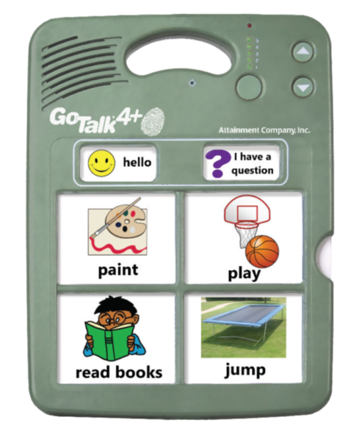  Purchasing Information  Users Guide  Users Guide Spanish Version  Cleaning Instructions  Video

Who Might Benefit?
Those who…
• Are difficult to understand or have unreliable speech.
• Have difficulty expressing ideas, feelings, needs, wants.
• Exhibit frustration or anger because others are unable to understand their communication attempts.
• Struggle socially with peers because of communication difficulties.
• Have difficulty understanding only oral directions given by others.
• Have difficulty understanding and completing multi-step activities (schedules, routines, directions).
• Have adequate fine motor skills to isolate a finger to poke the communication cell or press a switch to activate the device. This skill is specific to this device, however there are many different access methods that can be used with other communication devices if needed.
Why Use?
Provides an opportunity to…
• Make choices.
• Comment more effectively to others.
• Engage in multiple shared communication exchanges.
• Hear verbal directions paired with a visual cue as many times as needed.
Instructions for Use: | Adaptation Ideas:
Environmental Considerations  - Easily use in almost any environment because of the small size, weight, and easy transportability.  - May be difficult for some communication partners to hear in unusually loud environments.  - Use each recording level to record messages based on the environment like the classroom, lunchroom, playground, bus, and at home.  - The user of the device will need to learn when it is appropriate to use the device in quiet environments in the same way that children who are speakers learn when they need to talk or not talk in quiet environments.  - If used as a part of a child's total communication system it should be available in all the child's environments, at all times, and without restriction.  Positioning  - Use laying on a flat surface such as a table or on the floor. It would be possible to mount the device on an articulating arm mount if needed. A child could interact with the device in a position such as sitting, standing, prone (Tummy Time position), supine (laying on their back), kneeling, etc.  Alternate Positioning  - Use on a slant board to improve physical and/or visual access of the device to the child.  Basic Play/Use  - The GoTalk 4+ Lite Touch User Manual provides clear and concise directions for setting up the device, along with troubleshooting common problems encountered by new users. Pictures are also included to support the written directions if needed.  - Symbol overlays used on the device to represent the recorded vocabulary are not included with the SuperTalker FeatherTouch. Overlays can be created for this device using GoTalk DESIGN, Boardmaker, or LessonPix. All of those are apps, software programs, or online products for purchase. If you do not have access to one of the overlay making programs mentioned, hand-drawn pictures or photos can also be used to create the paper overlays.  - Messages will need to be recorded for each cell. It is recommended that a child similar in age and gender to the child who will be using the device provide the recordings.  - Recorded messages (words, phrases, and sentences) need to be relevant to the child’s immediate activities.  Extended Play/Use  - Instruction: Provide directions, such as what to wear or what's next on the schedule.  - Requests/Choices: Make requests, such as choosing snack food, asking a question, requesting a song, selecting a toy, requesting more, choosing a musical instrument to play at circle time, indicating a need for a sensory break (I need headphones, I need to jump/run, I need to swing), etc.  - Participation: indicating the weather (rainy, sunny, snowy, etc.) during circle time, speaking the repeating lines of a book for choral reading with other children, one to one counting of objects out loud.  - Information sharing: Share information, such as upcoming events or activities, sharing the day and month during calendar activities.  - Communication: Add communication to toys or appliances. | Optional Additional Materials/Supplies  - Velcro, Dycem, cabinet liner  - Foam Board  - Laminating Pockets  - Photo or Slide Pockets  Build It Up  - If the size of the cell is too small for the child to activate there are other single message devices available in the OCALI Lending Library that have larger activation surfaces. Alternatively, Velcro a plastic bottle cap to the button to build up the surface.  Simplify It  - This device can be made more simplistic by using objects or photos as the symbol sets on the overlay, which are often considered the most simplistic forms of symbols.  Stabilize It  - Velcro on most surfaces or place Dycem to help stabilize it so it doesn’t move away when the child tries to activate the button.  Add Sensory Cues  - Add to the activation button- puffy stickers, puffy paints, different textures. The background color of the cell, if needed.  Alternative Uses  - One of the eight levels of the device can be dedicated to a classroom weekly theme, responses to calendar queries, counting, or a storybook, and can be changed out and re-recorded as needed.  - Consider using as a non-individual student device available to classroom peers, to support center activities (i.e., provide step-by-step directions, vocabulary enhancement/building) or for adult modeling of AAC use.  DIY Alternatives  - Paper communication systems can be used when speech generating devices are not available or are not appropriate for the activity (e.g. water play where exposure to moisture may damage the device, loud environments where the speech generated by the device can not be heard, etc.). Paper communication systems can be made by using one of the overlay maker products such as Boardmaker or LessonPix. They can also be hand drawn and created.

Resources:

Making the Most of Multiple Message (3,4, and More) Voice Output Devices - Enabling Device provides ideas on ways multiple message static display communication devices can be used at home, school, and the community.

Plan for AAC Throughout the Day - Suggestions from AssistiveWare on how to incorporate AAC devices in everyday activities.

